**Route basics:** We can define our routes in the web.php page.

* Below is an example, this defines that all get request in the homepage will result in a response with view named ‘welcome’ (a blade page in the view folder)

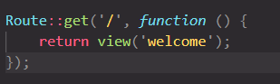

* This below example, sends a string response. Laravel automatically convert it to a http response

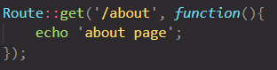

* This example, the request is handled by the index method of the ContactController x (it’s a controller class). Note, this doesn’t work on Laravel 8.



Laravel 8 format is as follows,



* We need to import the controllers in case we using them in the route function.



**URL and URL To:**

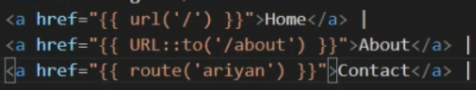

* **Url:** url() Generates an absolute URL to the given path.
* **URL::to:** this takes to a specific link
* **Route:** This is used for named route, sometimes we have long routes that we don’t want to repeat, we can define name in the controller and use that name in the link

